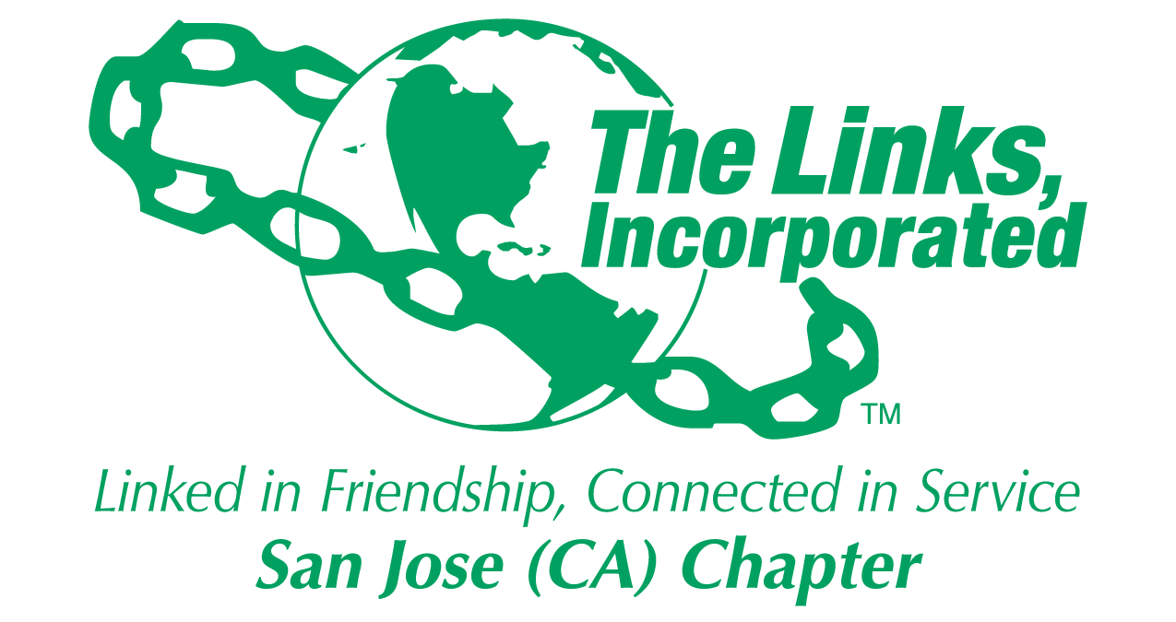

2017-2018

YEARBOOK

General Information
Color: Green and White
Flower: White Rose
The Links Pledge:
I do solemnly pledge myself to all the ideals, purposes and true meaning of the word “Friendship” as embodied in the name “Links.” I shall earnestly endeavor to uphold these standards and do my share toward serving my community and my chapter to the best of my ability. And this I promise. ~Written by Sarah Strickland Scott

The National Song
We strive to do some good each year, For those who need our aid; It binds us close and brings us joy, And so we feel repaid. We’re each a Link in friendship’s chain and loyal to our creed of doing good through work and play Together we’ll succeed.
The Links Incorporated Founders Date: November 9, 1946
San Jose Chapter Founders Date: June 6, 1981

Executive committee
President Tracy Bowers
Vice President Membership Norwita Williams Powell
Vice President Programs Naomi Alston
Recording Secretary Teri Zanders
Corresponding Secretary Katranker Thompson
Treasurer Jessie Dunun
Financial Secretary Pam Payton
Parliamentarian Yvonne Waldron Robinson
Chaplain Vickie Wilson
Immediate Past President Fredia Brooks
Arts Facet Chairpersons Pam Payton and Yvonne Waldron Robinson
HHS Facet Chair Natasha Joplin
ITS Facet Chairpersons Vickie Wilson and Hellen Sims
NTS Facet Chairpersons Roselyn Harlow and Vieira Whye
STY Facet Chairpersons Lisa Dixon and Toni Brown

1. Allocations Committee Vacant
2.Archives Committee Hellen Sims
3. Audit Committee Pam Payton, Jessie Dunun
4. Bylaws Committee Yvonne Waldron Robinson
5. Communications & Public Relations Mary Noel
6. Ethics and Standards Committee Natasha Joplin
7. Finance Committee Jessie Dunun
8. Fundraising/Fund Develop Com Lisa Dixon
9. Integrated Programs Jan White
10. Membership Committee Norwita Williams Powell
11. Nominating Committee Vacant
12. Protocol Committee Brenda Ray
13. Rituals Committee Malaika Young
14. Scholarship Committee Malaika Young
15. Social Committee Roz Harlow
16. Strategic Planning Committee Katranker Thompson
17. Technology Committee Vacant
18. Desserts for Charity

ADMINISTRIVIA 101

Service hours
- Active members of The Links, Incorporated are required to accumulate a minimum forty- eight (48) hours of service per fiscal year to the organization through service sanctioned by and a part of her Chapter’s programmatic thrust. Service hours may also be earned by attending Chapter meetings, participation in Chapter activities, participation in certain Area meetings as may be designated by the Area Director, and participation in certain National meetings as may be designated by the National President. The one-year period mirrors the fiscal year of The Links, Incorporated i.e., May 1st through April 30th. Members may project an estimate of service hours that will be accumulated after the Chapter’s submission of its Master Data Form and by April 30th if necessary. Chapter leadership is responsible for ensuring the integrity of the service hours reported.

- Our chapter tool to manage service hours is the Track it Forward application. https://www.trackitforward.com

Fiscal Information
- How do I receive my refund? The Treasurer, Pam Payton
- Who is in charge of funds? Who do I contact first? Financial Secretary, Jessie Dunun
- What is a voucher? Why can’t I get my funds without it? The Voucher System is our way of maintaining an audit trail for any and all funds that have been expended.
- How important is the budget for this year? Very Important – Without Budgetary discipline, we will not be able to finance our Community Projects.
- What does the budget look like? The Treasurer can supply you with a copy of the budget.

Bylaws
- What categories of members are in this chapter now?
  - Active
  - On-leave
  - Alumnae & Platinum
- Who is the chair? The Parliamentarian – Yvonne Waldron Robinson

Archives
- Who is the archivist for this chapter? Hellen Sims

Protocol
- Who is in charge of protocol? Brenda Ray
- What do they do when an area or National officer comes to visit our chapter? Refer to Protocol Manual
- Is there a National manual? YES Why is it important? It is the designated process to give the respect to the office of the person visiting.

Publicity
- Who is in charge of publicity for our chapter? Publicity Chairperson, Mary Noel
  - What have we done in the past?
  - Deltas Advertisement
  - Alpha Kappa Alpha Ad
  - Delta Sigma Theta Ad
  - African-American Center AD
  - Selectmen of San Jose Ad
  - Western Area Advertisement (odd yrs.)
  - Peninsula Chapter of Links
  - Sacramento Links
  - San Francisco Links
  - National Assembly Ad (even yrs.)

Branding our Chapter
- Where do we start? Why is it important? Should it be a part of the work of the publicity chairperson? Branding allows us to partner with a larger segment of our community and more easily raise funds to promote our charitable works.

Social Committee
- Who is the chairperson of the committee? Roz Harlow
- What activities for the chapter do they plan? Christmas Social, work with the Protocol Chair to plan Charter Day and Founders Day.

Chapter contracts/ Email /web Account

- Chapter Address
  - POB 3691,
  - San Jose, California 95126
- Website Address: www.sanjoselinks.org
  - Username sjlmember
  - password:2$ervE
- Email Address: sanjose@linksinc.org
- Username: sanjose
- Password: 33388

National and Western Area Websites:
- Western Area http://walinks.org/ p/w westernarea54
- National http://www.linksinc.org

Scholarship Committee
- Who is the chairperson of the committee? Malaika Young
- Is there a program to mentor the students? Yes, a more formalized process has been established by the Committee.

Adopt a Family
- Who is the chairperson? Jan White

cOMMUNICATIONS

- Contact the Chapter President regarding any issue which may affect the Chapter prior to the meeting.
- RSVP means regrets only or as requested
- Practice email etiquette. When replying to "EMAILS"- Avoid replying as: "Reply to All"- Reply to sender or requestor

CHAPTER MEETINGS
- Contact the Meeting Hostesses by the RSVP date/deadline. If you are unable to attend, leaving early, or arriving late to the meeting.
- Chapter Meeting notification is expected - two weeks before meeting
- Meeting Hostesses sends the meeting announcement to Corresponding Secretary (and cc: the President) two weeks prior to the meeting.
- Corresponding Secretary sends Chapter Meeting notifications within two weeks prior to the meeting.
- Fees incurred by the Hostesses as a result of "no shows", or "no response" may require the member to reimburse Hostesses for meal cost or other items related to planning the meeting.

eXECUTIVE COMMITTEE MEETINGS
- Executive Committee Meetings attendees are: Elected Officers, Facet Leads, Standing and Appointed Committee Chairs- Attendance is required and RSVP courtesies apply for Executive Committee Meetings.
- Anyone making a report at the Chapter Meeting must first present the report to the Executive Committee Meeting.
- Chapter Wide reports are to go through President, and Corresponding Secretary
- Individual reports for other members, committees to go directly to the Chair of the Committee first, then presented to Executive Committee, and then at the Chapter meeting.

All meetings are governed by the current (11th)edition of the Robert's Rule of Order

TELEPHONE CALLS

- Telephone calls are expected to be returned with 48 hours.
- Reply to phone calls and take actions within the requested timeframe

TE LINKS , INCORPORATED NATIONAL CALENDAR May– April

MAY | 1  1  1  5/1-6/30  >  >  >  >  > | Beginning of Fiscal Year  Deadline for receipt of late dues, assessments, and fees for non-financial members at National Headquarters  Membership transfer period begins  Installation of Chapter Officers (Chapter Profile Update Form emailed to National Headquarters at membership@linksinc.org with a copy to Area Directors) Chapter conducts Orientation Workshop III for candidate’s induction [use Membership Orientation Manual & History Book]  Induction of new members [New members may be inducted beginning 5/1 and ending 6/30]  Evaluation of chapter activities [see Membership Orientation Manual]  Chapters may begin to submit Form 990 to IRS and Chapter bonding insurance to  National Headquarters  Area Conference [Odd years only – Date & location TBD]  Memorial Day [Headquarters closed]
JUNE | >  > | Establish all committees for new Chapter year  Induction of new members [New members may be inducted beginning 5/1 and ending 6/30]  Area Conference [Odd years only – Date & location TBD]
JULY | >  4  >  > | National Assembly- [Even Years Only- Date and location TBA]  Area Conference [Odd years only – Date & location TBD]  Independence Day [Headquarters closed]  For Area Elections -- Area Nominating Committee sends  nominating forms to Chapters; Chapters distribute forms to members for elections to be held at Area Conferences [Area elections are held in odd years only]  For National Elections -- National Nominating Committee sends nominating forms and  instructions to Chapters for elections to be held at National Assembly [National elections are held in even years only]
AUGUST | >  >  >  >  >  > | Chapter committee meetings and workshops conducted  Changes in Chapter bylaws, Chapter membership rosters, Chapter handbooks, etc., emailed to  Area Directors  Copies of Chapter bylaws sent to Area Parliamentarians  Chapter Executive Committee roster emailed to National Headquarters  [membership@linksinc.org] with a copy to Area Directors September mailing distributed to all Chapter  Presidents Governance Meeting [Odd years only – Date & location TBD]
SEPTEMBER | >  15  15  15  >  >  > | Labor Day [Headquarters closed]  Deadline for submission of 990 Tax Form to IRS [ALL Chapters are required to submit Form 990; go to www.IRS.gov for information] If a Chapter files for an extension with the IRS, a copy of the extension form must be sent to National Headquarters.  Deadline for submission of copy of 990 Tax Form to The Links, Incorporated [postmarked before or on September 15 and mailed to the National Headquarters] . Form can also be uploaded on the National web site.  Deadline for Chapter Bonding Insurance form to be processed online and payment postmarked/mailed to The Links, Incorporated lockbox or paid online  Postmark date for Chapter bonding insurance form and payment due at National  Headquarters [Must be submitted to lockbox]  Congressional Black Caucus Annual Legislative Conference (Washington, DC)  Black Women’s Agenda Workshop and Luncheon (Washington, DC)  Annual Walk-A-Thon
OCTOBER | >  >  15  > | Breast Cancer Awareness Month  Deadline for completed Profile for Nomination Forms for National Officer Elections mailed to National Headquarters [even years]  Chapter sends Chapter budget for Chapter Year to Area Director with a copy to Area  Treasurer  Membership Committee distributes candidate(s) profile forms to Chapter members
NOVEMBER | >  >  >  >  >  >  >  > | National Friendship Month  Chapters celebrate Founders’ Day  Executive Council Meeting [Date & Location TBA]  Scott Hawkins Leadership Institute Retreat [Date & Location TBA]  Veteran’s Day  Thanksgiving Day [Headquarters closed]  Day after Thanksgiving [Headquarters closed]  Candidates’ profile forms presented to Chapter members
DECEMBER | 1  24  25  26 | Deadline to submit member transfers  Christmas Eve [Headquarters closed]  Christmas Day [Headquarters closed]  Kwanzaa
JANUARY | 1  >  > | New Year Observed [Headquarters closed]  Martin Luther King Jr. Holiday Observed [Headquarters closed]  Chapters may vote on candidates for membership and submit candidate profiles and verification forms to National Headquarters and Area Director
FEBRUARY | >  1  >  >  > | Black History Month  Deadline for submission of Program Reports  President’s Day Observed [Headquarters closed]  Area Nominating Committee sends names of candidates for National Officers to Chapters  [National elections are held in even years only]  Chapters send letters to candidate(s) approved for membership [after the verification form is approved/signed and returned to Chapter President]
MARCH | >  >  >  >  > | Chapters begin processing membership dues online and submit payment online or to the  respective lockbox for The Links, Incorporated and The Links Foundation, Incorporated  Affiliate Members submit membership dues and service hours online to the National  Headquarters  Chapters send fees for new members to the respective lockbox for The Links, Incorporated and The Links Foundation, Incorporated (separately)  Chapters send letters to candidate(s) approved for membership [after verification form  is approved/signed and returned to Chapter President]  Chapter Conducts Orientation Workshop I for approved candidates [use Membership  Orientation Manual]
APRIL | 1  1  1  >  >  30 | Deadline membership dues to be processed online and payment submitted online or to the  respective lockbox for The Links, Incorporated  Chapters elect officers  Postmark deadline for Affiliate Members’ membership dues and service hours to be submitted  to the National Headquarters  Area Conference [Odd years only – Date & location TBD]  Chapter conducts Orientation Workshop II for Candidate(s) for induction [use Membership  Orientation Manual]  End of Fiscal Year

