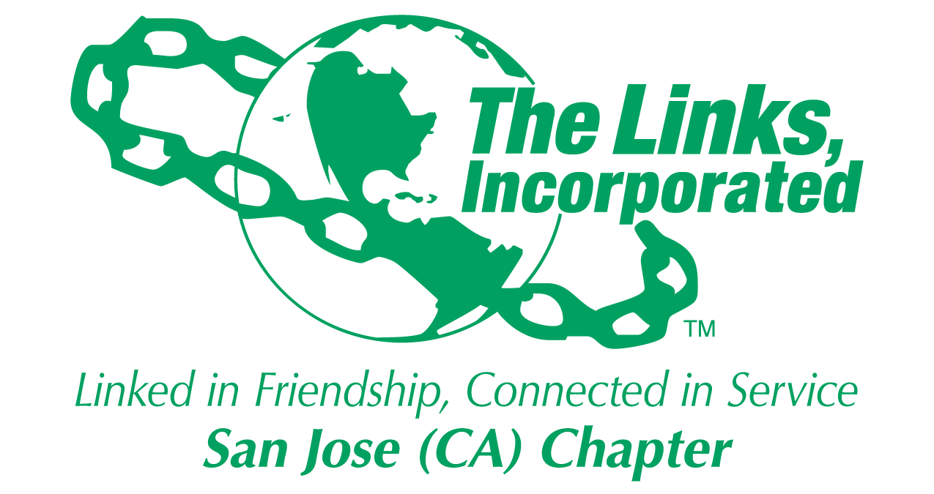

Post Office Box 3691

San Jose, CA 95156

E-mail: sanjoselinksinc.com